**Project Based Learning Report on**

**Mess Color Paradox**

Submitted to

Department of Computer Science and Engineering

Bachelor of Technology

in

Computer Science and Engineering

(2021– 2025)

E Saikiran 22R15A0514

B Prabhakar 22R15A0513

N Maneesha 22R15A0517

S Chandu 21R11A05E6

Under the Guidance of

Subject Faculty name



Department of Computer Science and Engineering

Accredited by NBA

**Geethanjali College of Engineering and Technology (UGC Autonomous)**

(Affiliated to J.N.T.U.H, Approved by AICTE, New Delhi)

Cheeryal (V), Keesara (M), Medchal.Dist.-501 301.

**August-2023**

TABLE OF CONTENTS

|  |  |  |
| --- | --- | --- |
| S.No | Index | Page No. |
| 1 | ABSTRACT | 03 |
| 2 | INTRODUCTION | 04 |
| 3 | OBJECTIVE | 05 |
| 4 | MODULES | 06 |
| 5 | CODE | 07 |
| 6 | OUTPUT | 27 |
| 7 | CONCLUSION | 28 |
| 8 | REFERENCES | 29 |

1. **ABSTRACT**

Mess Color Paradox is like Predict Like Puzzle is the type of game developed in Sketch code in the Arduino Uno. It is used to predict what Favorite color we picked in our mind by giving yes or no response to the device.

It is generally played in a paper craft but we are developed this with sketch , IOT Devices and built an IOT Device Model. If we don’t know the logic of puzzle it is very difficult, suspenseful and surprisal for every one who play with this puzzle

**2. INTRODUCTION**

The Mess Paradox Color Prediction Game (MPCPG) is a compact and captivating gaming innovation designed to entertain users by challenging their ability to identify color without exploring the user selected color inside the mind selected color within their minds, using the device as a medium of interaction.

This project introduces an immersive gaming experience where players engage with the system to predict a color chosen by the device which color player selected inside the mind, without any prior visual cues. Through a series of intuitive interactions, users navigate through a paradoxical challenge where their perception and intuition are put to the test.

1. **OBJECTIVE**

• **Engage and Entertain Users:**

* Provide a fun and interactive experience that challenges users' perception and intuition.

• **Challenge Users' Cognitive Skills:**

* Test users' ability to predict colors based on intuition without prior visual cues.

• **Promote Mindfulness and Focus:**

* Encourage users to develop and utilize their mindfulness and focus skills.

• **Create an Immersive Gaming Experience:**

* Develop a seamless and engaging interface that enhances the overall user experience.

• **Facilitate Intuitive Interactions:**

* Design intuitive interactions that guide users through the paradoxical challenge effectively.

**4. MODULES**

* **IR Sensor:**

An IR (infrared) sensor is a type of photodetector that detects the presence or absence of the color.

* **Servo motor:**

Servo motor is used to predict the output of the game.

* **Arduino Uno:**

It is the functions of setup() and loop(), which are called automatically in the background. The code to be executed is written inside the curly braces within these functions.

* **Breadboard:**

A breadboard (sometimes called a plugblock) is used for building temporary circuits. It is useful to designers because it allows components to be removed and replaced easily.

* **Connecting Wires:**

A connecting wire allows travels the electric current from one point to another point without resistivity.

**5. CODE**

#include <Servo.h>

int a = 0, b = 0, c = 0, d = 0, e = 0, f = 0, val = 0, i = 0,yes=0,no=0;

int count = 0;

int count1 = 0;

Servo Servo1;

Servo Servo2;

int ir1 = 7;

int ir2 = 4;

int sm1 = 10;

int sm2 = 9;

void setup() {

Serial.begin(9600);

pinMode(ir1, INPUT);

pinMode(ir2, INPUT);

pinMode(13, INPUT);

pinMode(11, INPUT);

Servo1.attach(sm1);

Servo2.attach(sm2);

}

void loop() {

Serial.println("Game started");

int yes, no,val1,val2,val3,val4,val5,val6;

int vallcall;

int yn;

servomotor1Rotate1();

yn=irInput(yn);

val1=yesNochecking(yn);

servomotor1Rotate2();

yn=irInput(yn);

val2=yesNochecking2(yn);

servomotor1Rotate3();

yn=irInput(yn);

val3=yesNochecking3(yn);

servomotor1Rotate4();

yn=irInput(yn);

val4=yesNochecking4(yn);

servomotor1Rotate5();

yn=irInput(yn);

val5=yesNochecking5(yn);

val = ((val1 * 10000) + (val2 * 1000) + (val3 * 100) + (val4 * 10) + (val5));

Serial.println("processing a,b,c,d,e values");

Serial.println(val);

if(val==1100)

{

Servo2.write(0);

delay(1500);

Servo2.write(10);

Serial.println("GOLD");

Serial.println(val);

delay(1500);

}

if(val==1000)

{

Servo2.write(0);

delay(1500);

Servo2.write(25);

Serial.println("BROWN");

Serial.println(val);

delay(1500);

}

if(val==11)

{

Servo2.write(0);

delay(1500);

Servo2.write(42);

Serial.println("DARK GREEN");

Serial.println(val);

delay(1500);

}

if(val==11110)

{

Servo2.write(0);

delay(1500);

Servo2.write(62);

Serial.println("DARK BLUE");

Serial.println(val);

delay(1500);

}

if(val==10)

{

Servo2.write(0);

delay(1500);

Servo2.write(77);

Serial.println("SKIN");

Serial.println(val);

delay(1500);

}

if(val==11011)

{

Servo2.write(0);

delay(1500);

Servo2.write(100);

Serial.println("WHITE");

Serial.println(val);

delay(1500);

}

if(val==111)

{

Servo2.write(0);

delay(1500);

Servo2.write(120);

Serial.println("RED");

Serial.println(val);

delay(1500);

}

if(val==10001)

{

Servo2.write(0);

delay(1500);

Servo2.write(135);

Serial.println("LIGHT GREEN");

Serial.println(val);

delay(1500);

}

if(val==11100)

{

Servo2.write(0);

delay(1500);

Servo2.write(150);

Serial.println("PINK");

Serial.println(val);

delay(1500);

}

if(val==10101)

{

Servo2.write(0);

delay(1500);

Servo2.write(170);

Serial.println("YELLOW");

Serial.println(val);

delay(1500);

}

for(;;){

Serial.println("Game Over");

}

}

void servomotor1Rotate1()

{

Servo1.write(0); // Set the servo position according to the mapped value

delay(1500); // Wait for the servo to reach the position

Servo1.write(80);

delay(2000);

}

void servomotor1Rotate2()

{

Servo1.write(0); // Set the servo position according to the mapped value

delay(1500); // Wait for the servo to reach the position

Servo1.write(100);

delay(2000);

}

void servomotor1Rotate3()

{

Servo1.write(0); // Set the servo position according to the mapped value

delay(1500); // Wait for the servo to reach the position

Servo1.write(120);

delay(2000);

}

void servomotor1Rotate4()

{

Servo1.write(0); // Set the servo position according to the mapped value

delay(1500); // Wait for the servo to reach the position

Servo1.write(140);

delay(2000);

}

void servomotor1Rotate5()

{

Servo1.write(0); // Set the servo position according to the mapped value

delay(1500); // Wait for the servo to reach the position

Servo1.write(160);

delay(2000);

}

int irInput(int yn)

{

Serial.println("Ir yes sensor taking input");

yes = digitalRead(ir1);

delay(1000);

Serial.println("Ir no sensor taking input");

no = digitalRead(ir2);

delay(1000);

return yes;

}

int yesNochecking(int yes)

{

Serial.println("Checking yes or no condition");

if (yes == 1) {

count = count + 1;

Serial.println("Count incremented");

Serial.println(count);

if (count == 1) {

a = 1;

Serial.println("a value initialized with 1");

return a;

}

if (count == 2) {

b = 1;

Serial.println("b value initialized with 1");

return b;

}

if (count == 3) {

c = 1;

Serial.println("c value initialized with 1");

return c;

}

if (count == 4) {

d = 1;

Serial.println("d value initialized with 1");

return d;

}

if (count == 5) {

e = 1;

Serial.println("e value initialized with 1");

return e;

}

}

if (no == 1) {

count1 = count1 + 1;

Serial.println("Count1 incremented");

Serial.println(count1);

Servo1.write(10);

if (count1 == 1) {

a = 0;

Serial.println("a1 value initialized with 0");

return a;

}

if (count1 == 2) {

b = 0;

Serial.println("b1 value initialized with 0");

return b;

}

if (count1 == 3) {

c = 0;

Serial.println("c1 value initialized with 0");

return c;

}

if (count1 == 4) {

d = 0;

Serial.println("d1 value initialized with 0");

return d;

}

if (count1 == 5) {

e = 0;

Serial.println("e1 value initialized with 0");

return e;

}

}

}

int yesNochecking2(int yes)

{

Serial.println("Checking yes or no condition");

if (yes == 1) {

count = count + 1;

Serial.println("Count incremented");

Serial.println(count);

Servo1.write(10);

if (count == 1) {

a = 1;

Serial.println("a value initialized with 1");

return a;

}

if (count == 2) {

b = 1;

Serial.println("b value initialized with 1");

return b;

}

if (count == 3) {

c = 1;

Serial.println("c value initialized with 1");

return c;

}

if (count == 4) {

d = 1;

Serial.println("d value initialized with 1");

return d;

}

if (count == 5) {

e = 1;

Serial.println("e value initialized with 1");

return e;

}

}

if (no == 1) {

count1 = count1 + 1;

Serial.println("Count1 incremented");

Serial.println(count1);

Servo1.write(10);

if (count1 == 1) {

a = 0;

Serial.println("a1 value initialized with 0");

return a;

}

if (count1 == 2) {

b = 0;

Serial.println("b1 value initialized with 0");

return b;

}

if (count1 == 3) {

c = 0;

Serial.println("c1 value initialized with 0");

return c;

}

if (count1 == 4) {

d = 0;

Serial.println("d1 value initialized with 0");

return d;

}

if (count1 == 5) {

e = 0;

Serial.println("e1 value initialized with 0");

return e;

}

}

}

int yesNochecking3(int yes)

{

Serial.println("Checking yes or no condition");

if (yes == 1) {

count = count + 1;

Serial.println("Count incremented");

Serial.println(count);

Servo1.write(10);

if (count == 1) {

a = 1;

Serial.println("a value initialized with 1");

return a;

}

if (count == 2) {

b = 1;

Serial.println("b value initialized with 1");

return b;

}

if (count == 3) {

c = 1;

Serial.println("c value initialized with 1");

return c;

}

if (count == 4) {

d = 1;

Serial.println("d value initialized with 1");

return d;

}

if (count == 5) {

e = 1;

Serial.println("e value initialized with 1");

return e;

}

}

if (no == 1) {

count1 = count1 + 1;

Serial.println("Count1 incremented");

Serial.println(count1);

Servo1.write(10);

if (count1 == 1) {

a = 0;

Serial.println("a1 value initialized with 0");

return a;

}

if (count1 == 2) {

b = 0;

Serial.println("b1 value initialized with 0");

return b;

}

if (count1 == 3) {

c = 0;

Serial.println("c1 value initialized with 0");

return c;

}

if (count1 == 4) {

d = 0;

Serial.println("d1 value initialized with 0");

return d;

}

if (count1 == 5) {

e = 0;

Serial.println("e1 value initialized with 0");

return e;

}

}

}

int yesNochecking4(int yes)

{

Serial.println("Checking yes or no condition");

if (yes == 1) {

count = count + 1;

Serial.println("Count incremented");

Serial.println(count);

Servo1.write(10);

if (count == 1) {

a = 1;

Serial.println("a value initialized with 1");

return a;

}

if (count == 2) {

b = 1;

Serial.println("b value initialized with 1");

return b;

}

if (count == 3) {

c = 1;

Serial.println("c value initialized with 1");

return c;

}

if (count == 4) {

d = 1;

Serial.println("d value initialized with 1");

return d;

}

if (count == 5) {

e = 1;

Serial.println("e value initialized with 1");

return e;

}

}

if (no == 1) {

count1 = count1 + 1;

Serial.println("Count1 incremented");

Serial.println(count1);

Servo1.write(10);

if (count1 == 1) {

a = 0;

Serial.println("a1 value initialized with 0");

return a;

}

if (count1 == 2) {

b = 0;

Serial.println("b1 value initialized with 0");

return b;

}

if (count1 == 3) {

c = 0;

Serial.println("c1 value initialized with 0");

return c;

}

if (count1 == 4) {

d = 0;

Serial.println("d1 value initialized with 0");

return d;

}

if (count1 == 5) {

e = 0;

Serial.println("e1 value initialized with 0");

return e;

}

}

}

int yesNochecking5(int yes)

{

Serial.println("Checking yes or no condition");

if (yes == 1) {

count = count + 1;

Serial.println("Count incremented");

Serial.println(count);

Servo1.write(10);

if (count == 1) {

a = 1;

Serial.println("a value initialized with 1");

return a;

}

if (count == 2) {

b = 1;

Serial.println("b value initialized with 1");

return b;

}

if (count == 3) {

c = 1;

Serial.println("c value initialized with 1");

return c;

}

if (count == 4) {

d = 1;

Serial.println("d value initialized with 1");

return d;

}

if (count == 5) {

e = 1;

Serial.println("e value initialized with 1");

return e;

}

}

if (no == 1) {

count1 = count1 + 1;

Serial.println("Count1 incremented");

Serial.println(count1);

Servo1.write(10);

if (count1 == 1) {

a = 0;

Serial.println("a1 value initialized with 0");

return a;

}

if (count1 == 2) {

b = 0;

Serial.println("b1 value initialized with 0");

return b;

}

if (count1 == 3) {

c = 0;

Serial.println("c1 value initialized with 0");

return c;

}

if (count1 == 4) {

d = 0;

Serial.println("d1 value initialized with 0");

return d;

}

if (count1 == 5) {

e = 0;

Serial.println("e1 value initialized with 0"); return e;

}

}

}

**6. OUTPUT**

* Choose your favorite color.
* Servo motor points to section 1 random color box.
* If your favourite colour in the colour box you have to place your hand before “YES” sensor else “NO” sensor.
* It will continue up to 5 colour boxes.
* After that servo motor 2 will point your favourite color.

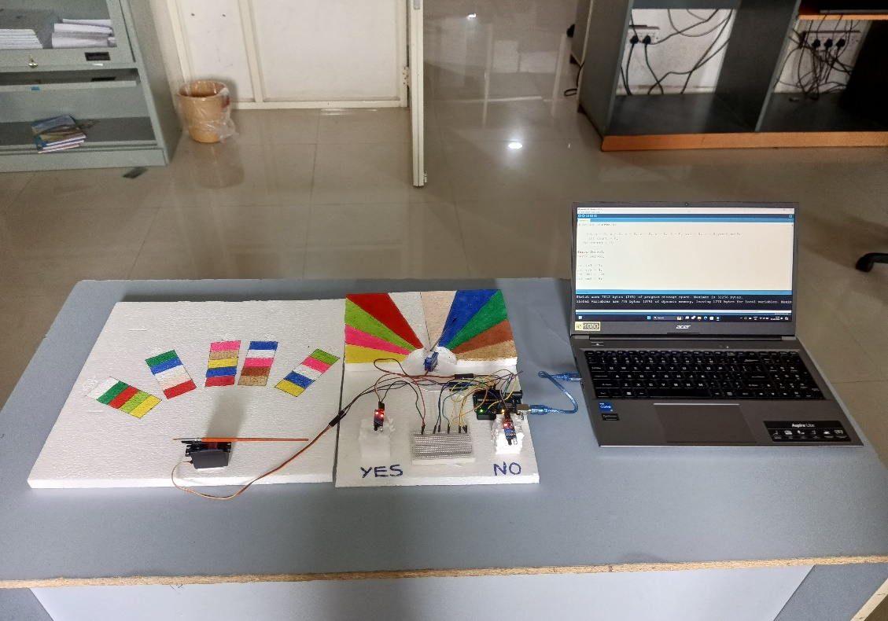

**7. CONCLUSION**

Our project is a game (Mess Color Paradox) that predicts the exact color chosen by the user in their mind without users telling to the device. The game displays random colors up to 5 times or more. If the user's chosen color is among the displayed colors, they place their hand on the 'yes' IR sensor; otherwise, they use the 'no' IR sensor. The user should provides some inputs according to the game requirements to identify the color chosen in their mind.

**8. REFERENCES**

1. [**h**ttps://github.com/EjumallaSaikiran123/IOT_PROJECT](https://github.com/EjumallaSaikiran123/IOT_PROJECT)
2. https://www.geeksforgeeks.org